INCAB
INCAB is the smartphone tracking and POD app for EVENT.
For APPLE and ANDROID.
Available to download from each store.
Connect to Event initially for data (Routes, Stops etc)

INCAB APP demo
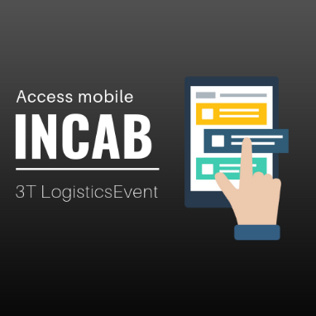
Click above to view demo. Screens and access.

*note some screens, links etc have been removed. This version demonstrates what screens, buttons and job status’s look like as a user moves through each Stop collection and delivery.
For example, discrepancy screens removed as not imported for this view of progress through INCAB

INCAB app screen flow
Below is a link to the app flow. Click on image and in top right ‘open in Chrome’.
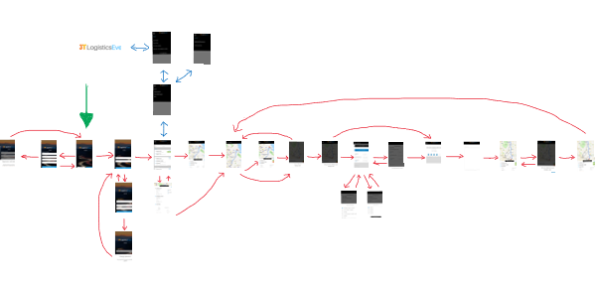

Design
The design can be seen from the APP demo and below screen by screen description.
For colours, buttons, actions, backgrounds, wording, flow…
The opening screen image is provided here:
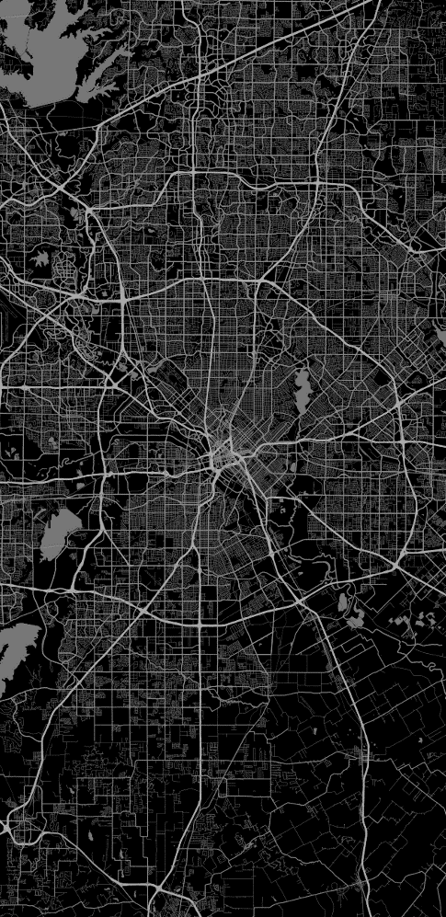

Where will the data come from?
The data will be sent to the app from Event.
This will be a carrier action from Event, from CONNECT (different document).
Carrier in CONNECT will allocate to INCAB.

Saving the button clicks
Each button must be user / date / time stamped against the Event Route ID and the STOP.
It will be used to populate, and update INFORM with this data.

Job status through the app per Stop:
- NEW - white
- IN PROGRESS - orange
- COMPLETE - green

Each Stop must go through these phases:
- Start Stop
- Arrived at Stop
- Departed Stop

The base process for the ‘journey’ through the app is as below:
- Login page
- Job list
- Job summary
- Job detail
- Start job
- Map
- Arrive at job
- Exceptions
- Rate service
- Sign
- Depart job

INCAB is designed primarily as a process for a driver. The Stops are in order of required delivery.
Sometimes it is required that they can change the sequence the want to deliver in.
They can do this by selecting the STOP in the Stop Summary screen.
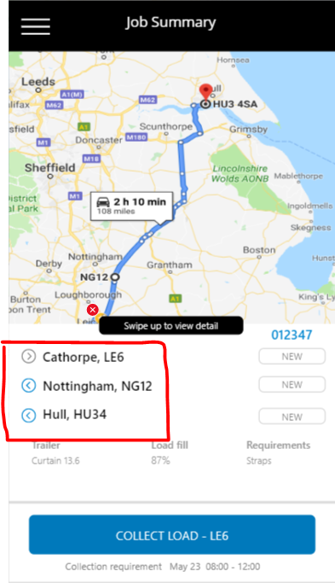
This will simply record the times for collection, arrival, delivery in the same way.
The status for the selected Stop must be updated.
The process for selection of the next Stop = always select the 1st ‘NEW’ status in the list in JOB SUMMARY and let the driver change as required.
Where the preceding Stop as been completed, INCAB will use the rule as above = all move to the next ‘NEW’ status for the next Stop to show after last has departed.

Stop 1 = New
Stop 2 = Complete
Stop 3 = New
In the above the driver selected to do Stop 2 1st. On completion INCAB will move to STOP 1. On completion of Stop 1 INCAB will move to Stop 3.

The INCAB screens
- OPENING SCREEN

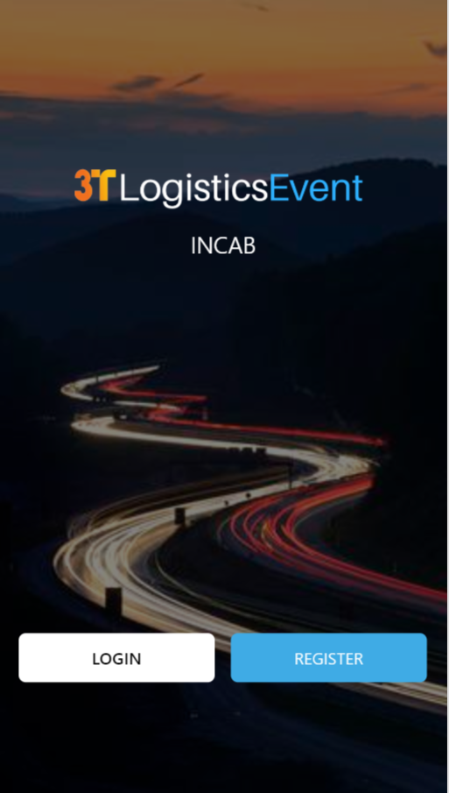
- Login in
Button takes user to Login page
- Register
Button takes user to Register screen

Login details will be created in CONNECT by the carrier through the Event invite process.

- LOGIN

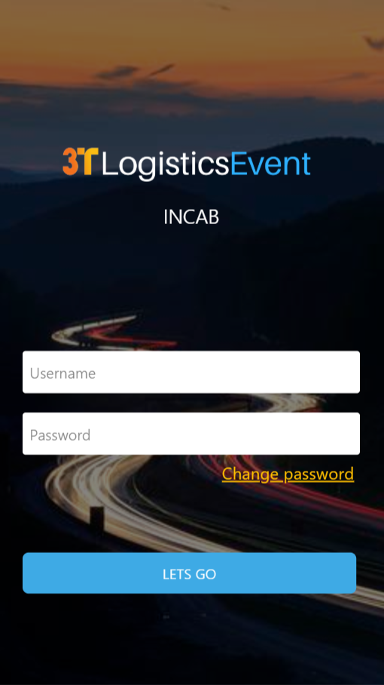
- Username
Text input.
This will usually be the drivers name. Created through CONNECT invite.
- Password
Text input
Needs not to be ‘easy’. Not 15 digits long
- Reset password
Link takes user to CHANGE PASSWORD screen
- Let’s Go (login)
Button

A driver is ‘INVITED’ to INCAB. Same process as a user being invited to DOCK.
Header section

- REGISTER (phase2)
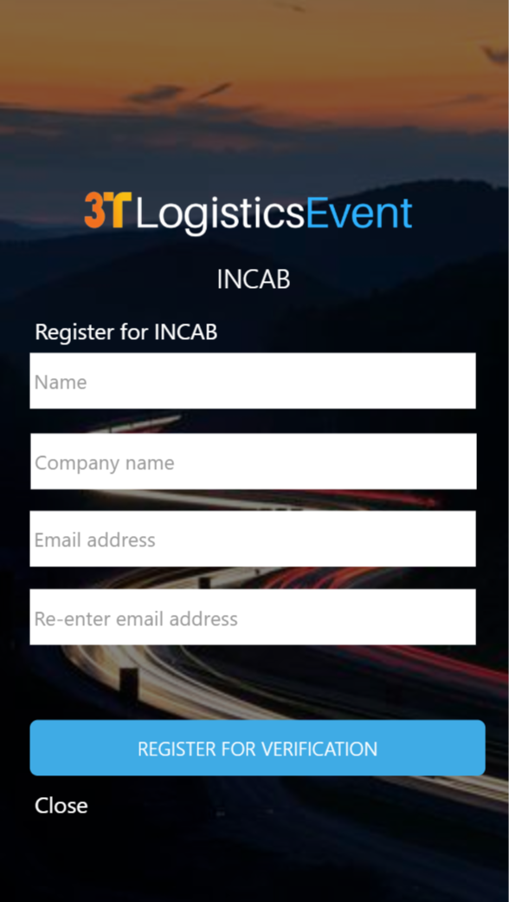

- Text box – user adds name
- Text box – user adds company name
- Text box – user adds email address
Do basic validation of email address format
- Text box – re-enter email address
Provide a error message if email addresses do not match
- Button – takes user to REGISTRATION CONFIRMATION screen
- CLOSE – link back to screen OPENING SCREEN

To go back to previous screen, user will use the phones ‘back’ button
Store these details and send then via email to antony.pratt@3t-europe.com.
Email title: New carrier registration for INCAB
Details: include name, company name and email address.

- REGISTER CONFIRMATION (phase2)
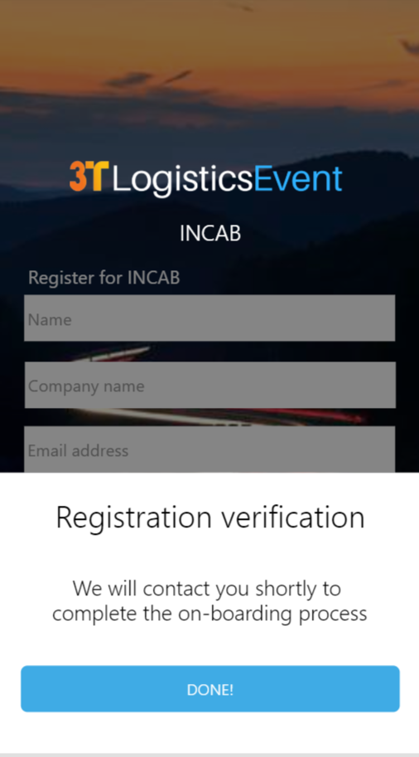

- Button – user will select to take them to screen OPENING SCREEN

- CHANGE PASSWORD (phase2)
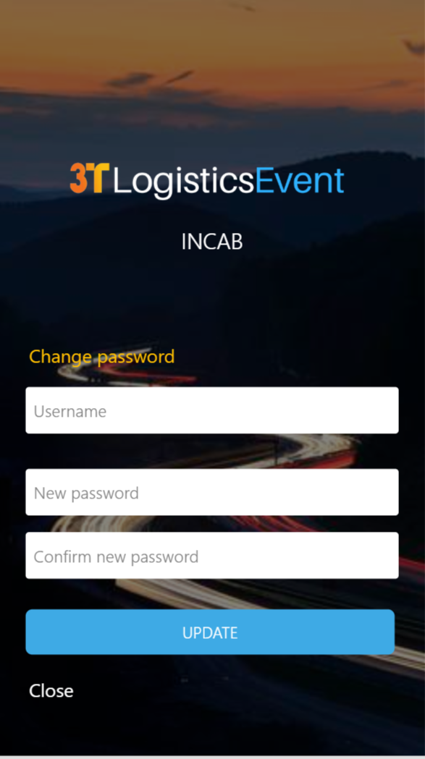

Requirement – for user to change password.
- Text box – user adds username
- Text box – user adds NEW password
- Text box – user re-enters
- Button – UPDATE. Takes user to PASSWORD CHANGE CONFIRMATION
- CLOSE – link back to screen LOGIN

To go back to previous screen, user will use the phones ‘back’ button
If user has forgotten username they will contact CONNECT owner
The user can change password by us just updating from current to new on this instruction on this screen, no email check etc…

- CHANGE PASSWORD CONFIRMATION (phase2)

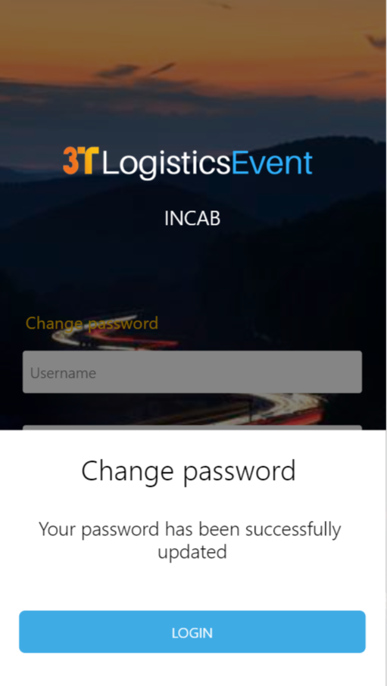

- Button – user will select to take them to screen LOGIN

7. Camera
It is a requirement that a user should be able to use the camera to take a picture at any point.
How?
If the user is on a screen for a Stop, the photo will be stored against the Stop
If the user is on a screen not related to a Stop i.e. the Route, it will be related to the route.
The photo icon will only be on screens from the JOB SUMMARY screen.
What?
Add a camera icon in top right of view. User can click to open. Taking picture will then take user back to last position.

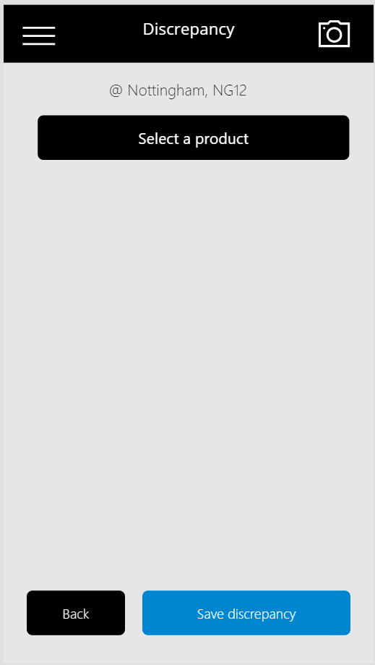

- JOB LIST

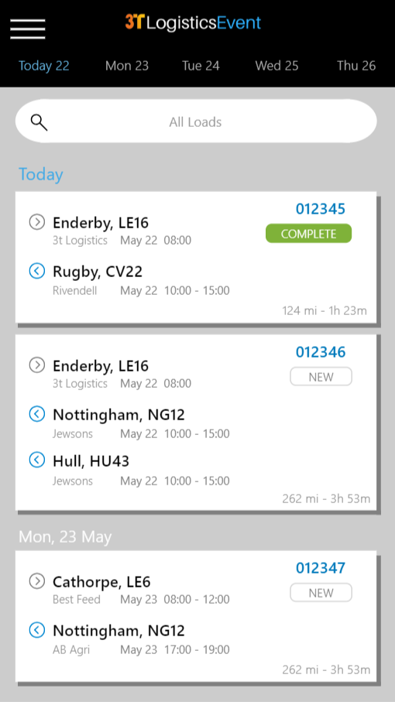
This screen will allow user to select a date and view the jobs for that date.
Jobs will be shown on tiles and each tile can be selected to open the job.
Job = Event Route ID, Stops etc

- Cheeseburger menu
Links to MENU screen
- Date selector
Finger swipe ‘left and right’.
Current date under menu icon as default. Swipe right to left to see more days.
Routes from Event are added based on Route collection date.
- Search
Search by job number only (Event Route ID)
- Tile for each Route / job
Tile includes data:
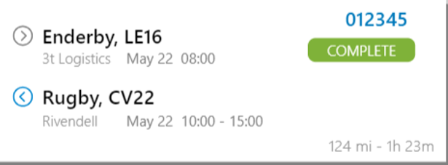
- Source point. Collection of goods
Town, Postcode stub
Name
Collection date (Month / date)
Collection time (could be a time window)
- Stops. Delivery points
Town, Postcode stub
Name
Collection date (Month / date)
Collection time (could be a time window)
- Event route ID (blue)
- Route / Job status
NEW (White, grey border)
IN PROGRESS (Orange)
COMPLETE (Green)
- Route / Job mileage
- Route / Job duration

NEW status
This is the default status. Before the Stop has been started.
Started = button in JOB SUMMARY has been clicked to open MAP screen.
IN PROGRESS status
This status is set to ‘in progress’ when the user has clicked on the start button in JOB SUMMARY and the MAP screen is opened.
COMPLETE
This status is set to ‘complete’ when the button in SIGN is pressed by the user.

The tile acts as one large button. Click to start Job.

Job offer action process for INCAB direct users only

Carriers using INCAB will be given the ability to action offered routes through CONNECT as current or now through the INCAB app directly.
A user of the app will need to be able to Accept and Refuse offers made to them from customers through INCAB itself.
This is aimed at the US and owner drivers where they have limited access to a PC.

The setting for INCAB route rejection / acceptance will be set in the INCAB desktop at initial setup by the carrier.
On setting, the carrier will be tagged to have all routes published directly to INCAB where they can be viewed, accepted / refused.
INCAB will be required to push some information back to Event so update CONNECT / ROUTE as well as INFORM. (including accept or refusal, refusal reason etc)

We will add a new status to the JOB SUMMARY page. It will be called ‘Accept offer’
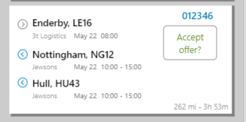
Job status on JOB SUMMARY for INCAB only users will be:
- Accept offer?
- Refused
- Start
- In progress
- Etc etc

The Route will be sent to INCAB. It will need to have a tag on it from Reece to say it’s a direct upload (i.e. no CONNECT accept / refusal). Because of this we will know to set status to ‘ACCEPT OFFER?’ and follow this process until job accepted.
User will click on the job box, see image above, to follow accept process.

Load offer screen
Once clicked on the below view will show. See image below.
The function will need to be a fixed height but include a scroll function as necessary. (see blue vertical line)
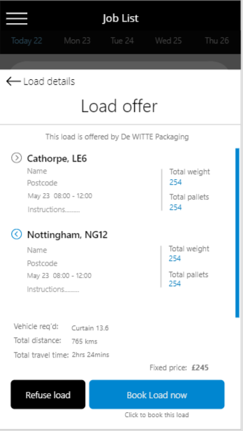

The link at the top will go back to the JOB SUMMARY page.
The customer name is shown (‘De WITTE’)
The details for the job are as above in the image.

Please also add the following:
- The vehicle type
- The total distance
- The total travel time
- The route cost (total cost)
Buttons:
- Refuse load = go through reject load process (see 3rd image below)
- Book load now = go to screen below

Load booked screen

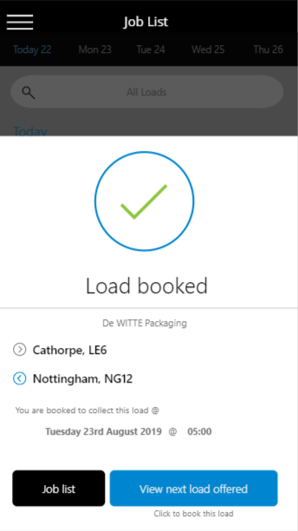

This screen will be a fixed height with scroll function as required.
Will show fixed image at top and title.
Will show customer name.
Will show top line from each Stop
Will show fixed text ‘You are booked to collect this load @’
Will show the booking details. The date @ time

How do we get the time. Event will provide you will the DOCK slot along with the route information.
You will need to simply store it and show it here.
To change this time, they will need to use CONNECT.
Buttons:
- Job List = link to Job List
- View next load offered = we will identify the next load with a status of ‘Accept offer?’ and open the ‘Book load’ screen for it.

Job list from accepting an offer
When the carrier has accepted the job we will show the status for the job / route as START.
Next status will then be IN PROGRESS as normal.
See below.
Now the user can click on the job tile to move to the next
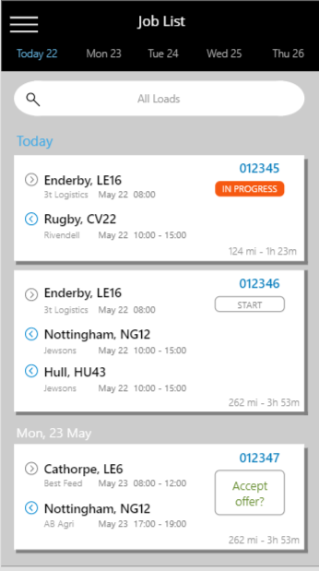

Refusing a load
A carrier can refuse to do a load offered.
They will click on the
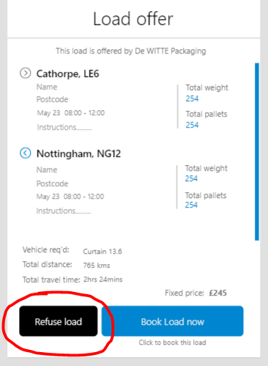
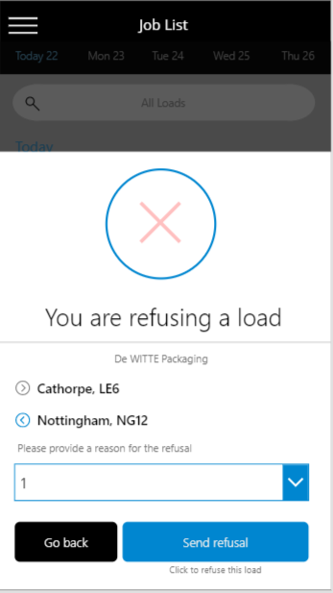

The image at the top is fixed. The red cross is very washed out.
The title is fixed
The customer name will show
The top line from each stop will show
We show fixed text ‘Please provide a reason for the refusal’.
The drop down will be populated from information sent from Event. The user will need to select 1 reason before the buttons are activated. The dropdown will need to show a default selection in the box of ‘Please select a refusal reason’

The buttons will be visibly ‘washed out’ until validation is complete (selection from dropdown)
Buttons:
- Go back = back to LOAD OFFER screen for the load / Route / job
- Send refusal = moves to the next screen LOAD REFUSED

Load refused screen
This screen provides confirmation of the refusal to the carrier.
You will need to send back to Event:
- The refusal for the route, at Stop level.
- These reason code for the refusal.
- Remove the job tile from the JOB SUMMARY screen

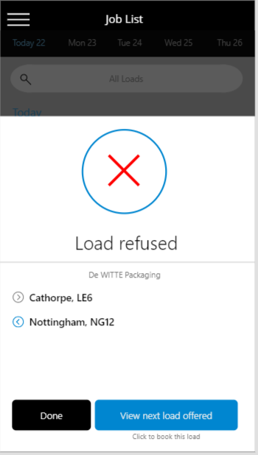
The image at the top is fixed. The red cross is now FULL bright red.
The title is fixed
The customer name will show.
The top line from each stop will show

Buttons:
- Done = back to JOB SUMMARY screen
- View next load offered = we will identify the next load with a status of ‘Accept offer?’ and open the ‘Book load’ screen for it.

8. JOB SUMMARY
The main job summary screen will also have a map version.
The user can click to view in map mode.
This view will be a map. It will show all jobs on the above job summary.
User can manipulate map to zoom into an area.
Clicking on the icon will open the job in the same way as it does on the Job Summary tile version.

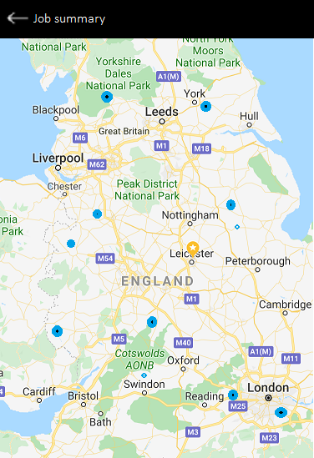
This screen also needs to show the users current position.

- JOB SUMMARY
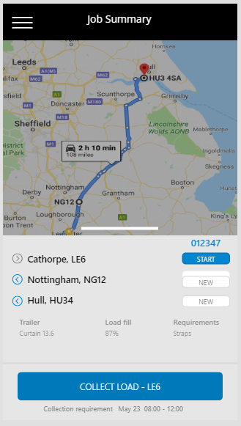
Above is the view when viewed by the user for the 1st Stop to be started.
This is the Job Summary screen.
Shows the user the summary, map of route and base information.
Actions:
- Menu link. Takes user to ‘MENU’
- ‘Swipe upto view detail’. User will ‘push up’ to open detail of job. Takes user to ‘JOB DETAIL’ screen.
- Stops. User can click on each Stop to change the starting Stop. Currently in this image its set by default to the 1st one – Cathorpe. As indicated by the START status. This is the default for INCAB.
User can open JOB DETAIL screen, click on ‘Nottingham’ instead. Button at bottom will show NG12 now.
See app ‘3 Stop demo’
Screen would look like below. Stop 2 is now in progress and button is updated…

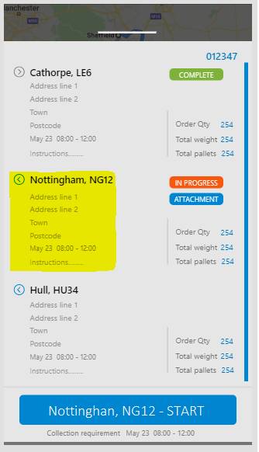

- Button - will show the postcode for the 1st Stop in the list that = NEW, unless point 3 overrides this. Takes user to ‘MAP’ screen.
Under the button is the collection or delivery date and window
- Document attached – icon will show user that there are attachments for this delivery

Data to show
- Map of Route
- Event route ID
- Source town and postcode stub
- Source name
- Source collection date and time
- Dest town and postcode stub
- Dest name
- Dest collection date and time
- Stop status
- Equipment type
- Load fill %
- Requirements – mapping from Event tbc

Attachment screens
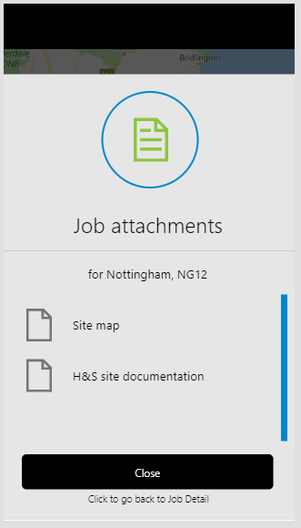
A job (Stop) can have any number of attachments.
These are viewable only, user cannot upload here.
These are added against the location (coming soon) and will be added or from DOCK document upload. These are stored against the Route and Stop.
User will select the document icon on the Job Summary page to view the attachment list.
Documents and images can be clicked on from the document icon to open for the user to see / read.
App will stay open.
User will click close to go back.

Example of Job Summary screen and corresponding detail screen when at start
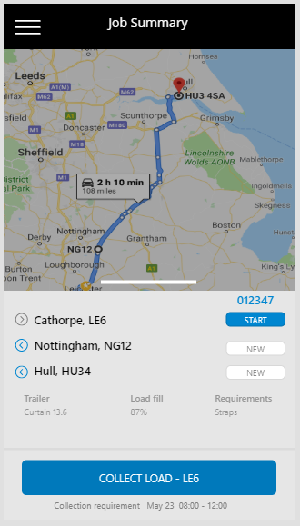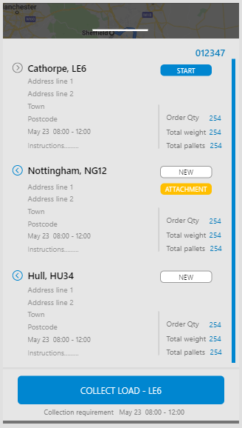
Example of Job Summary screen and corresponding detail screen when collection complete
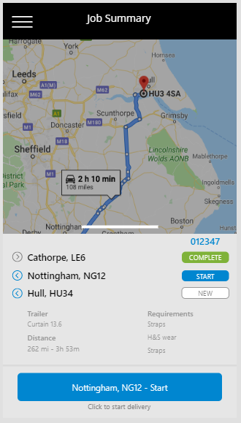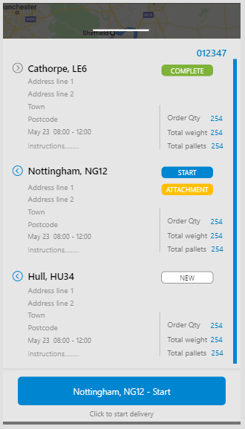

- JOB DETAIL

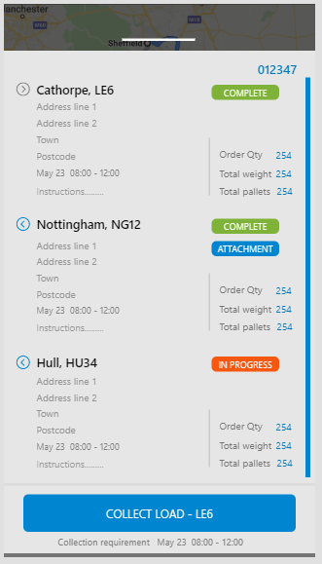
How does this screen work?
It is the base of the JOB SUMMARY screen. The user can ‘flick / swipe’ up the screen on the SWIPE action button. This will ‘push’ the screen up and replace the summary data with the below (and in image)
Button etc will stay the same.
User can only get to this screen from the JOB SUMMARY screen using the SWIPE action button.
The detail is scrollable as they may be many Stops and instructions.

What data is required?
- Route ID
- Source town and postcode stub
- Source name
- Source collection date and time
- Dest town and postcode stub
- Dest name
- Dest coll / delivery date and time in format above.
- Instructions for Stop
- Order quantity as despatched – number of packages
- Total weight as despatched – for Stop
- Total pallets – HU’s for Stop.
Actions:
- ‘Swipe down to view summary’ icon / function
- Button - will show the postcode for the 1st Stop in the list that = NEW, unless point 3 overrides this. Takes user to ‘MAP’ screen.

Under the button is the collection or delivery date and window
Same button etc as the JOB SUMMARY screen
User can navigate to
1. map
2. swipe back to JOB SUMMARY
3. view any attachments

Example – detail when on collection Example – detail when Nott to deliver
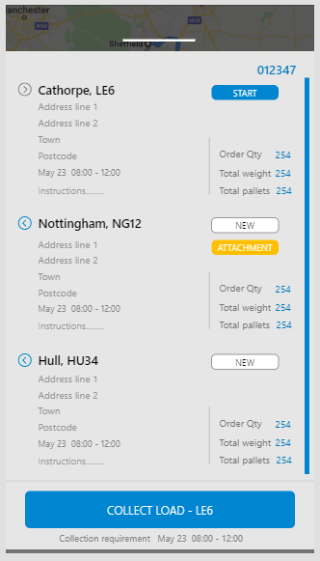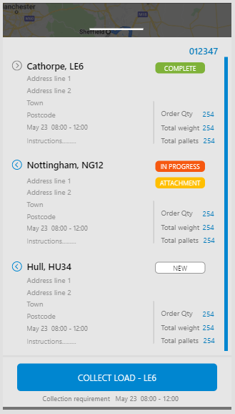

10. CONFIRM COLLECTION
This screen will show any attachments that are linked to the Stop.
Event will need to pass INCAB any documents, in form of:
1. PDF
2. Image (TIFF, JGEG etc)
If there is an image for a Stop, we will need to show in the JOB DETAIL screen
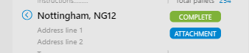
User will click on the ‘ATTACHMENT’ to navigate to the screen below.
We will need a process to be able to view the attachments.
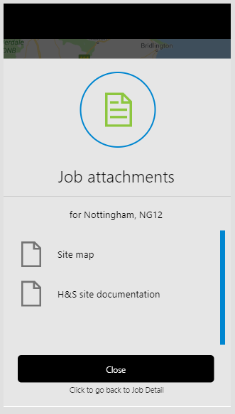
Button:
1. Close = navigate back to the JOB DETAIL screen.

11. CONFIRM COLLECTION
This will be a configurable screen. For now, please add to the flow.
Add it.
We will need to be able to store the entry made by the carrier, so create process to enable send back to Event.
Make sure that the collection line is now set to COMPLETE
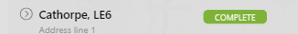
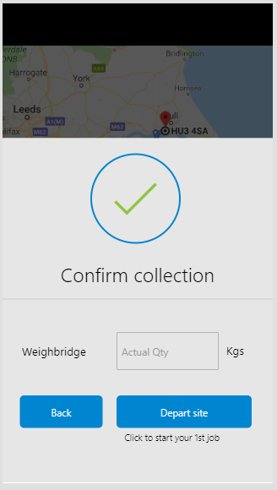

This section is configurable in Event INCAB.
See ‘Configuration in Event’ at end of this document. This will allow user to include this screen or not and if they do what they want to input (weight, plts, security number, signature)
User will add in the number of the weight and click button to open map.
We will store in new field the Collected Weigh Bridge weight.

Button:
1. Depart site = navigate back to JOB SUMMARY
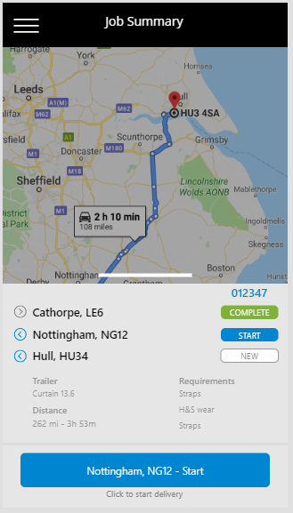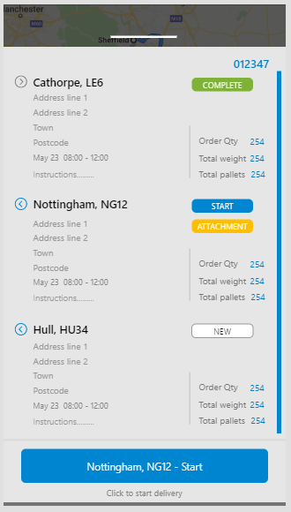

Once the collection has been completed, you can see the change above to the status and the button.
12. MAP
Clicking on the button, ’Nottingham, NG12 – Start’ will navigate to the map screen as the delivery is now in progress.
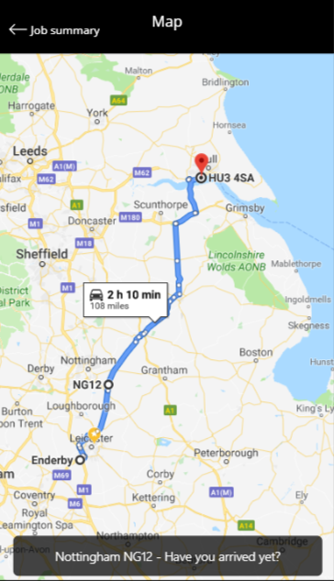
This is the map view.
Use inbuilt mapping to provide the:
- Complete Route from current position
- Arrow at top of page to direct user back to ‘JOB SUMMARY’ screen
- Button at bottom of map screen. Will take the user to the ‘ARRIVED AT DELIVERY’ screen
They can get a status view, check details, go back to map etc
The button will show the current collection / delivery based on the one currently in progress.

- Will have normal map touch (scroll, pinch etc)
- User cannot click on it to go anywhere
- It is not currently a SATNAV

Actions:
- Arrow at top of page – takes user to the JOB SUMMARY screen. This will be the summary screen they have already accessed, not a new screen.

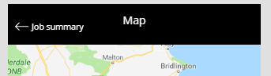

As the job has already been started and is in progress , the status will be updated to ‘IN PROGRESS’ and the black button will show ‘Continue’. It will navigate the user to the ‘CONTINUE’ screen.

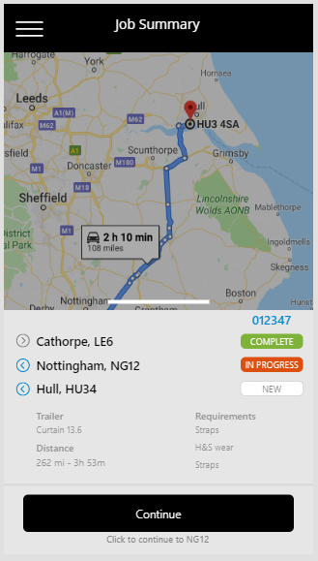

Example below of the In progress for 1st delivery for the JOB SUMMARY and DETAIL screens

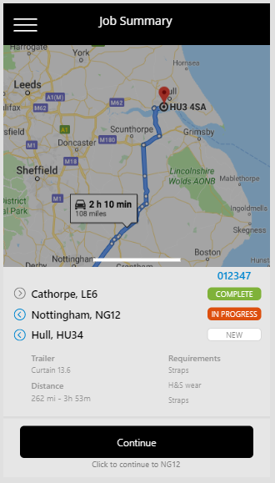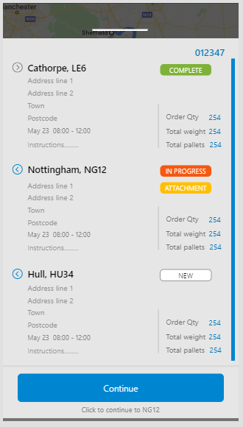

- Black Button on the map – will show the text ‘[current delivery town and postcode] – Have you arrived yet?’
If selected will take the user to the ‘CONTINUE’ screen

- Continue?

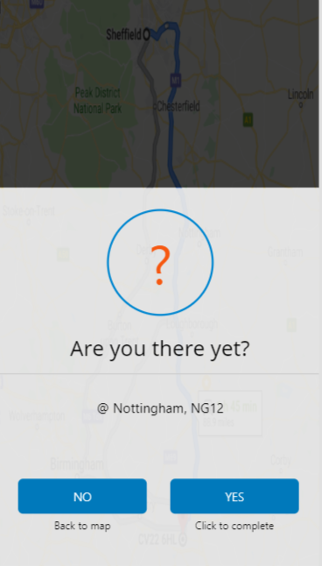

- Button ‘NO’
Select to go to MAP screen. Map button will show the same Stop town and postcode
- Button ‘YES’
Select to go to DELIVERY ISSUES screen
- ‘Nottingham, NG12’ text
This is the current ‘INPROGRESS’ STOP linked rom the map. This screen can only be accessed from the map screen.

- Delivery issues?

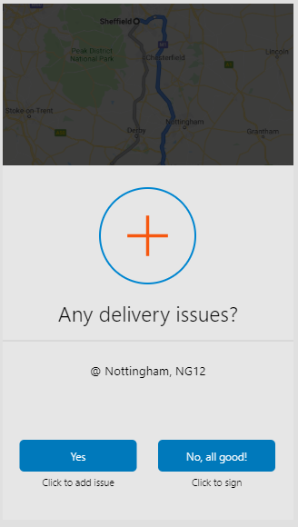
- Button ‘YES’
Select to go to RECORD ISSUES screen
- Button ‘NO, ALL GOOD!’
Select to go to CONFIRM DELIVETY screen
- ‘Nottingham, NG12’ text
This is the current ‘INPROGRESS’ STOP Town and postcode stub.

Replace ‘delivery’ with ‘collection’ depending on the data provided from Event.

- Confirm delivery
This is a configuration screen.
Please build the screen into the flow. We will then create a configuration for it so that it can be included / left out of the flow and the confirmed type changed.
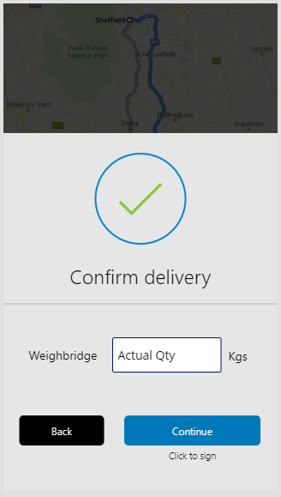

The user will add the value requested. We will store in the database.
Please see INCAB configuration document

Button:
- Back = back to ‘ANY DELIVERY ISSUES’
- Continue = to ‘RATE DELIVERY’

- RECORD ISSUES
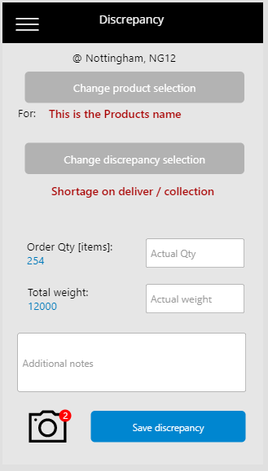

This describes each part of this screen. Not how it works (i.e some buttons will be deactivated until other actions completed) See next item.
Note: this is the overall screen once the user has completed it.
- Current Stop Town and postcode.
- Button ‘SELECT PRODUCT’
Directs user to SELECT PRODUCT screen.
Once a product has been selected the button will change to ‘Change product selection’ and change colour.
- Product name
Populated once above screen in point 1 has been completed. Red
- Button ‘SELECT DISCREPANCY’
Directs user to SELECT DISCREPANCY screen
Populated once above screen in point 1 has been completed
Once a product has been selected the button will change to ‘Change discrepancy selection’ and change colour.
- Order quantity (configuration selection)
Show planned order quantity for Stop. Total packages
This is not editable. Might not be available.
Add text box with title. User can add in a number as the Actual Total order quantity (packages).
- Total handling units (configuration selection)
Show planned Total Handling Units for Stop
This is a required field
Add text box with title. User can add in a number as the Actual Handling units (Pallet Qty).
- Total weight (configuration selection)
Show planned total weight for Stop
This is not editable
Add text box with title. User can add in a number as the Actual Total Weight.
- Additional notes
Text box.
User can type in additional text.
- Camera
User can click icon to open camera.
User can take multiple images.
Can we show the number of images taken. Naran has created a nice feature for this already.
- Button ‘SAVE DISCREAPANCY’
Directs user to ARE YOU SURE DISCREAPACIES screen

Delivery issues screen view after screen DELIVERY ISSUES? See app demos for flow….

- SELECT PRODUCT

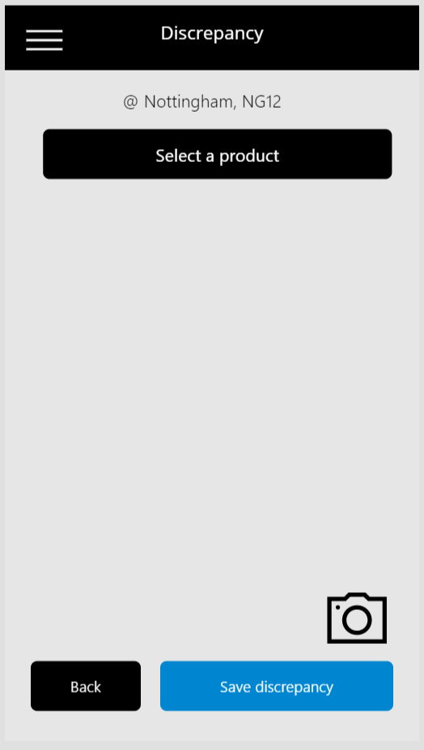
Only the following functions will be active at this point
- ‘SELECT A PRODUCT’ button
- Camera button
- BACK button (back to ANY DELIVERY ISSUES screen
- The ‘SAVE DISCREPANCY’ button

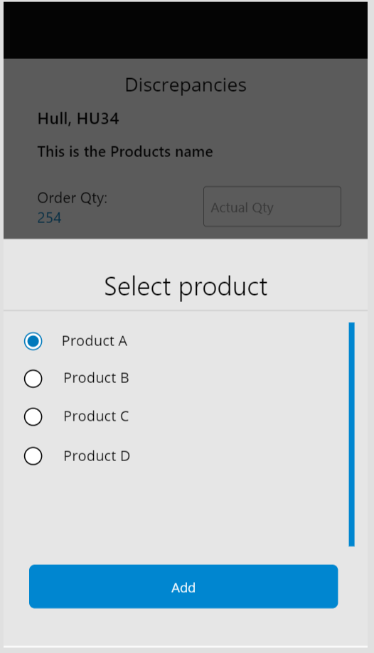

In this screen the user will select a product that has the discrepancy.
The product types are taken from Event, passed to INCAB with the STOP detail.
Button:
ADD = navigate to the Discrepancy screen (see below)

- RECORD ISSUES PRODUCT

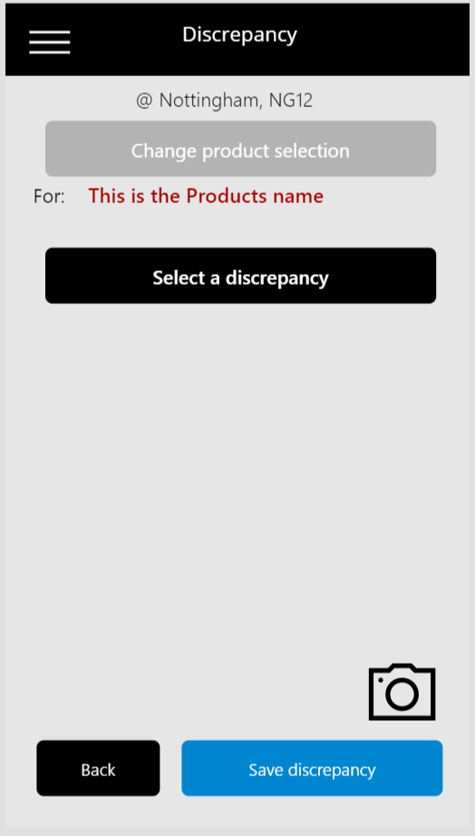

Same screen as RECORD ISSUES.
Difference =
- From the previous screen, selecting Products, add the selected product to screen
- Product has now been selected and shows on screen.
- SELECT DISCREPANY is now active to select
Actions:
- Menu link
- Button - Select Product
- Button - Select Discrepancy
- Text entry - Update Actual values in text entry boxes
Not editable until a discrepancy has been added. Show as greyed out box
- Text entry - Add additional notes (max 500 characters)
- Take multiple images / photos
- Button - Save discrepancy

- SELECT DISREPANCY
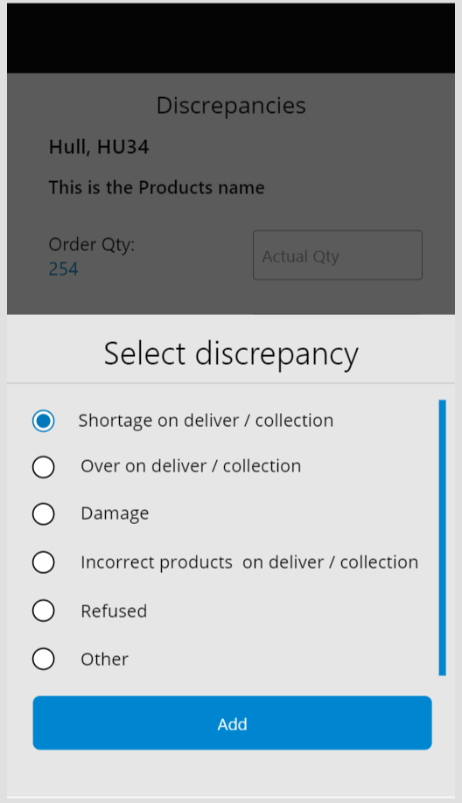

The user has selected to select the Discrepancy relating to the Product on the Stop that has the issue.
1. Show these default discrepancy types.
Show them in a list as above
2. Radial button
All set as blank to start with
User select oly 1 discrepancy
On selection radial button will go blue
3. User selects Button
Redirects to RECORD ISSUES DISCREPANCY screen

- RECORD ISSUES DISCREPANCIES

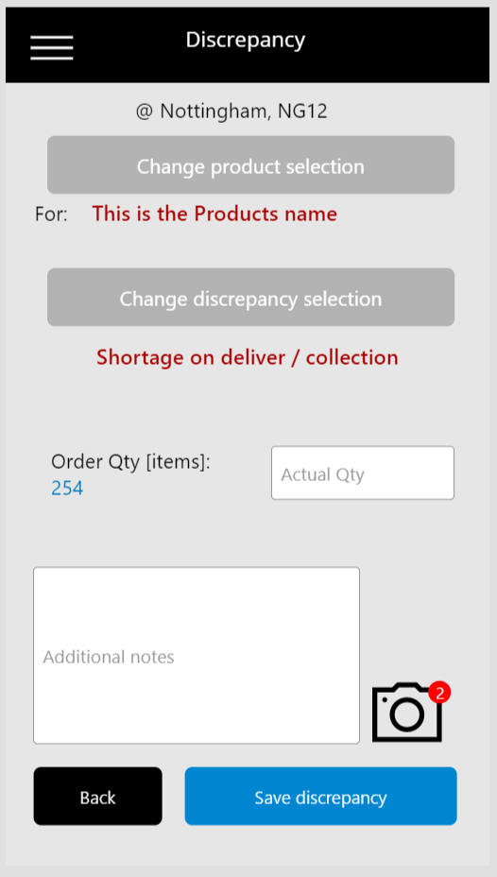

Same screen as RECORD ISSUES.
Difference =
- From the previous screen, selecting a Discrepancy, add the selected Discrepancy to screen in red.
- Activate the ‘ACTUAL’ text boxes.

Configuration.
This will be a configuration, stored in Event that will update this Discrepancy section to be Account specific.
The ones seen are the default

- ARE YOU SURE DISCREPANCIES?

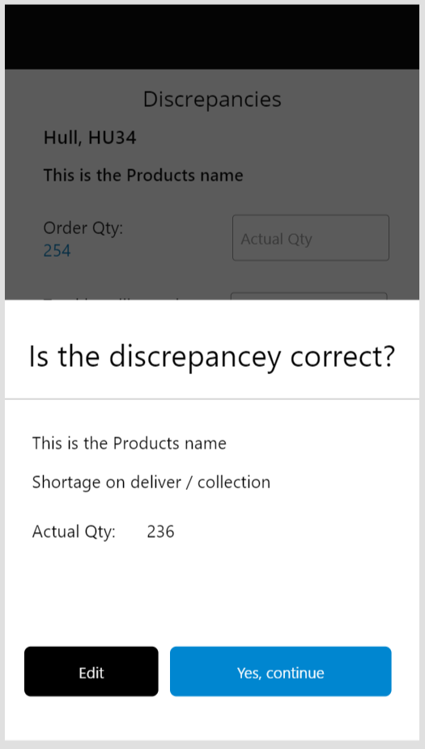

- Button ‘EDIT’
Select to go back to RECORD ISSUES screen
Populate as stored before ‘SAVE DISCREPANCY’ button was selected
- Button ‘SAVE DISCREPANCY’
Select to go to RATING screen
It is important that the user can see ‘most’ of the screen underneath. The RECORD ISSUES screen. So, they can confirm its correct.

- RATE DELIVERY

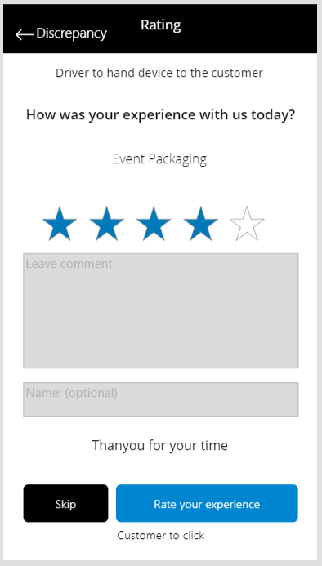
This screen is a default screen and cannot be removed in a configuration.
The user through can skip it.
It is for the driver to hand to the customer so that they can complete it.
We will need to store this data against the Stop.
- Star rating (1 to 5)
- Comment
- Name
Buttons:
- Arrow to left at top of screen = If the user selects this button it will take the user BACK to the screen ‘DISCREPANCIES’
- SKIP button = If the user selects this button it will take the user to the screen ‘SIGN’
- Button ‘RATE your EXPERIENCE’ = will take user to SIGN screen

Text on the screen:
Driver to hand device to the customer
How was your experience with us today?
[the Customer (SOURCE) of the product] i.e. WEIR / James Walker
Thankyou for your time

5 Rate star rating:
Stars will be white when not selected.
Blue when selected
User will select a star by running finger over them
Default is NO stars selected.
A user does NOT have to select stars to add notes and click a button.

Leave comment (optional):
This is a text box. User has 500 characters.
It does not have to be completed.
Needs to throw up a full keyboard. If possible, can be on screen writing. Preferably both.

Name (optional):
Entered using a keyboard.
Optional

- SIGN
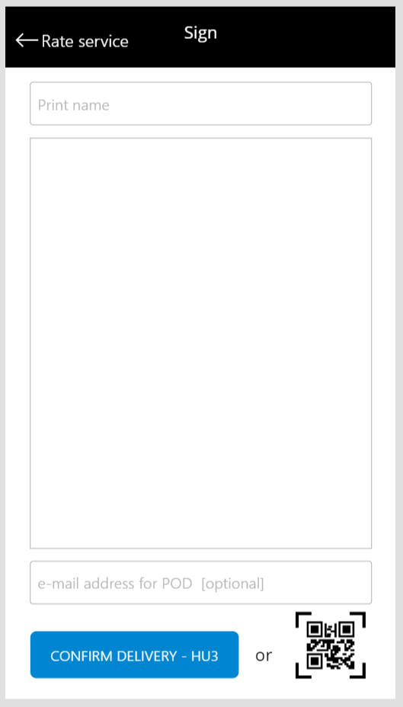

Actions:
- Text box – for adding name of person signing.
Show a keyboard
This must be added.
Deactivate sign, POD and SAVE functions until added.
Once added, reactivate
- Drawing function - Signature strip, finger sign.
This must be added.
Deactivate SAVE function until added.
Once added, reactivate
- Text box POD – this function is not required. If added, on save we will automatically send ePOD (completed template) to the email address.
- Button – ‘CONFIRM’ sign. Include postcode for the current STOP being signed for.
On clicking the user will be taken to ‘DEPARTED DELIVERY’ screen.
- Scan icon – This will open the scan screen

See below for exception until name and sign fields completed.
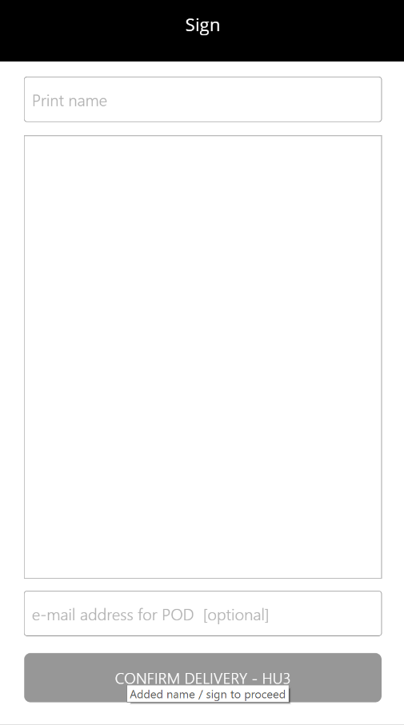

- SCAN [QR code]

https://hackernoon.com/react-js-qr-code-scanner-with-webworker-in-background-7a8bcefd43d
This is a process for 24/7 or Out of Hours delivery receipt.
Where the delivery point is closed or has not goods in receipt.
They can create a QR code that contains a digital signature that can be scanned by the driver as a receipt.
How does this process work?
- The scan / QR code is a button.
- When clicked it will instigate a scan process with the phone by opening the camera,
- The user will scan the QR code
- The QR code, once successfully scanned will return a 6 digit code.
- The code will be stored as the delivery signature
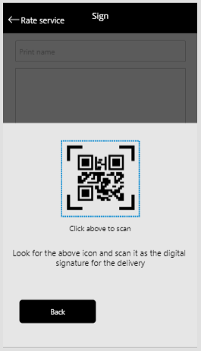

Below is the scan image.
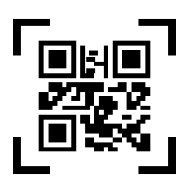

The above image is the button to activate the scan function.

- Delivery Scan Success
When a user has scanned the QR code at the delivery point successfully they will get this screen.
Button: CONTINUE = navigate to DEPARTED SITE YET
There is no ‘go back’ at this point.
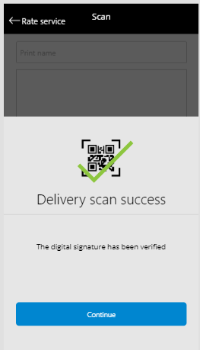

- Delivery Scan failure
When a user has scanned the QR code at the delivery point unsuccessfully they will get this screen.
Button:
CONTINUE = navigate to DEPARTED SITE YET
TRY AGAIN = go back to SCAN page and try again.
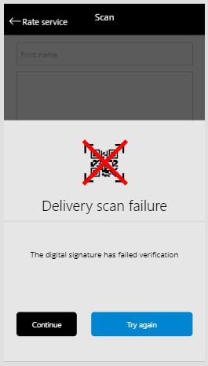

- DEPARTED DELIVERY
When the driver has got the delivery signed for they will need to provide a status to tell Event that they have departed site.
The screen will show them the delivery they have just completed and are currently sitting outside of.
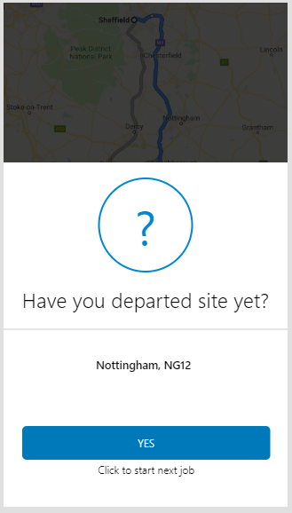

Button:
- YES = takes driver to…see below
The JOB SUMMARY screen. Updates the status and shows the next job in the button POINT 18
If this is the last Stop, then takes the driver back to the JOB LIST screen. POINT 19

- NEXT TRIP IN ROUTE
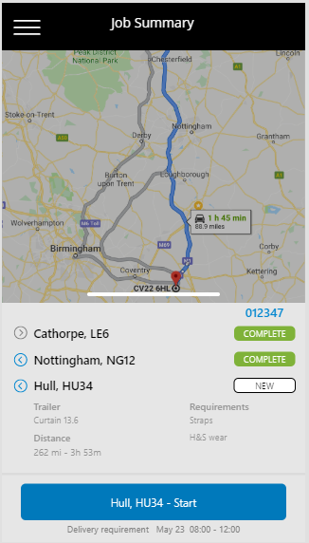
When the user has click ‘Yes’ in the Departed Site screen and if they have another STOP in status NEW, then they will be taken to the screen above.
This screen is the same as JOB SUMMARY. It is differentiated by the BUTTON description.
It shows the next Stop to be started and the last Stops complete
The driver has just completed the last Stop and we are now showing him the next Stop he has to do.
We start the cycle again going back to the JOB SUMMARY screen.
The differences are based on the progress of the Job.
- The Stop status will be updated based on what’s been completed
The next
- Button – will show the next Stop to be started.

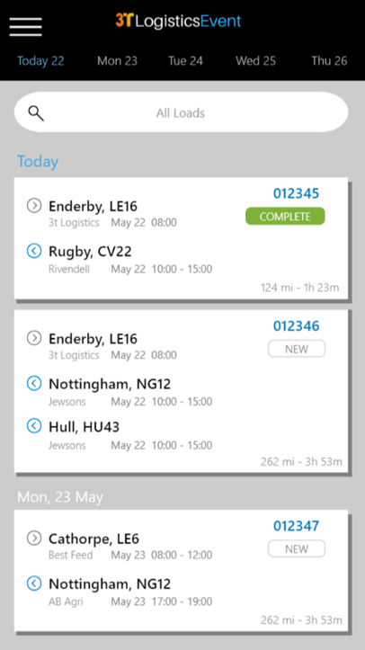
When the driver has completed a Stop on a Route and there are NO other Stops in Status NEW (all Stops are in Status COMPLETE) then they will be taken to the JOB LIST screen.
This screen is only shown when ALL Stops are in COMPLETE status on a Route.
Any Route completed will be shown in this screen.

- INCAB MENU
The menu screen can be reached from all screens that have the ‘hamburger icon’ in the top left.
If the user clicks on the menu icon in DISCREPANVY page they will need to be able to navigate back to the same point again if they repress the menu icon in the menu screen.

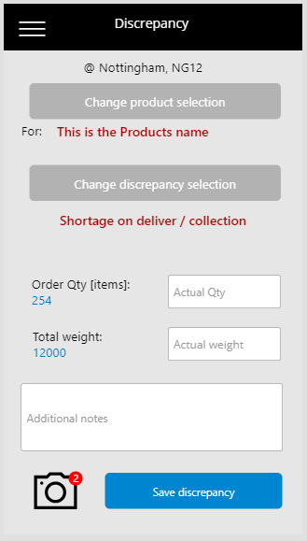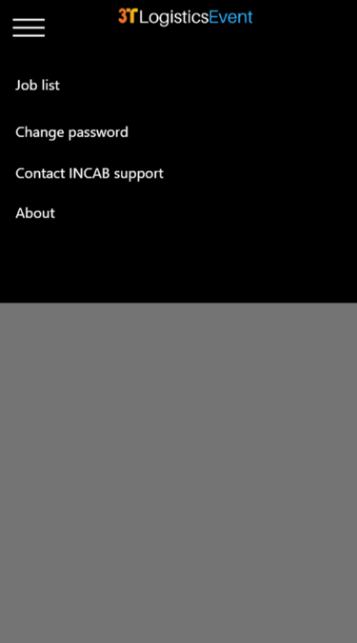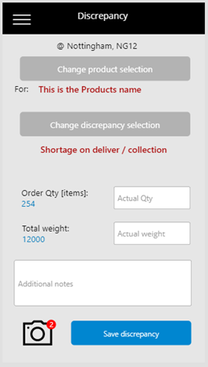

While the user stays in the MENU screens the ‘burger’ menu icon will be a go back to their current place in the app.
Example 1:
Discrepancy screen (current place in app)
Clicks menu to get INCAB support number
Gets support number
Clicks ‘burger’ menu icon to go back to discrepancy screen.

Example 2:
Discrepancy screen (current place in app)
Clicks menu to get to JOB LIST screen.
Menu is now closed
To get back to Discrepancy screen……
User clicks on the Route in JOB LIST, clicks on current Stop and INCAB takes them to the last place they were on that Stop (Discrepancy screen, as they did not press the action button at the bottom of the screen, so are still active in it)

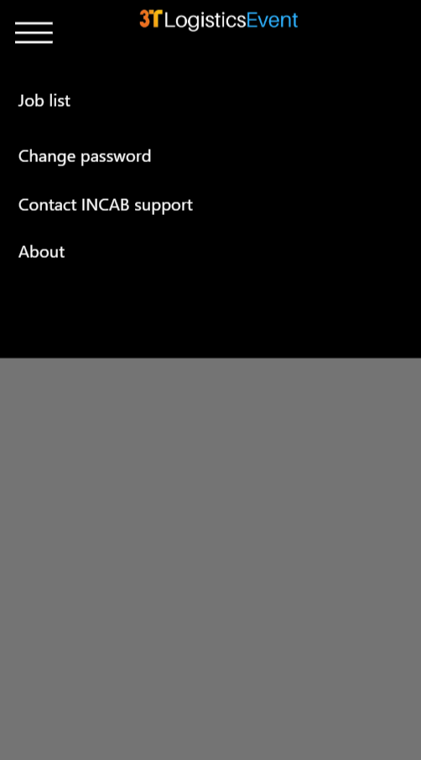

- Job list, Link to: JOB LIST screen
- Change password, Link to: CHANGE PASSWORD screen
- Contact INCAB support, Link to MENU screen: MENU CONTACT
- About, link to screen: MENU ABOUT
Use MENU icon to close menu

If user clicks on MENU icon they are taken back to last page place…

- MENU ABOUT

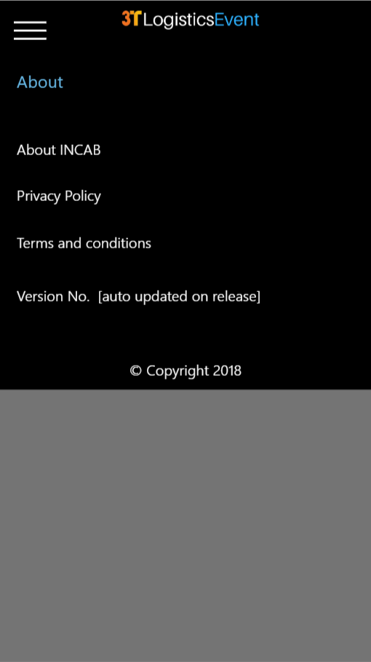

- About INCAB
Link to : https://www.3t-event.com/incab
- Privacy policy
Link to: https://www.3t-event.com/incabterms
- Terms and conditions
Link to: https://www.3t-event.com/incabterms
- Version number
To auto update for each release?
- App year copyright
To auto update each year
Use MENU icon to close menu

- MENU CONTACT

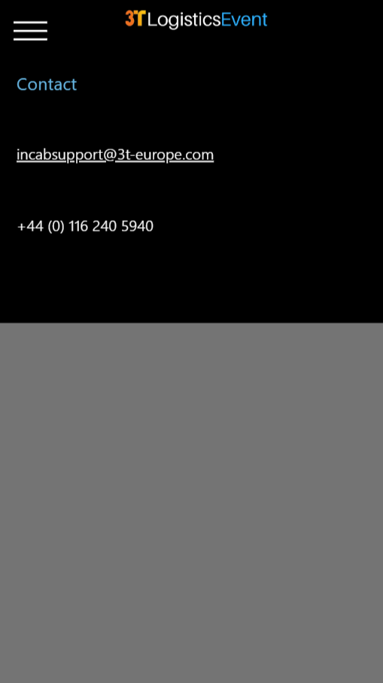

- Link by email to: incabsupport@3t-europe.com
- Text phone number
Click menu icon to close menu

1. 2.
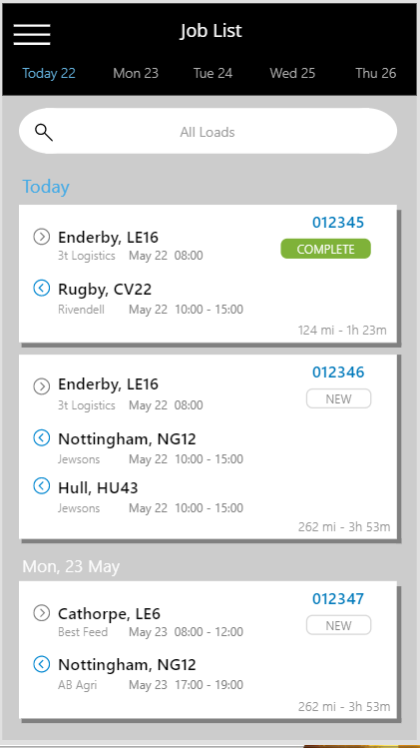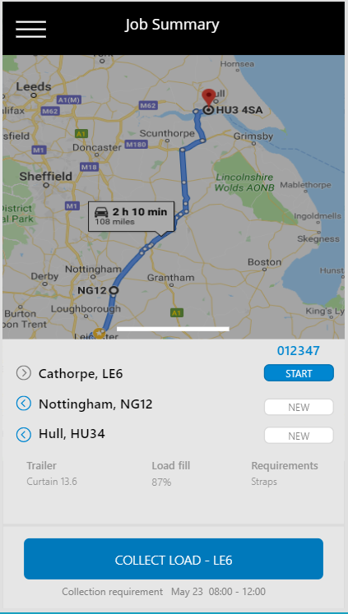
3. 4.
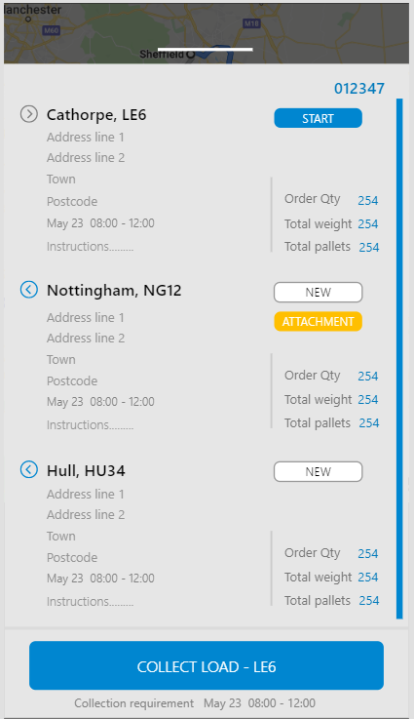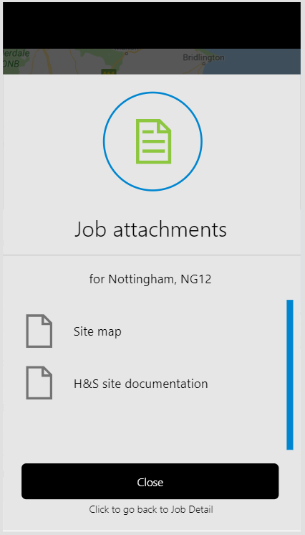

5. 6.
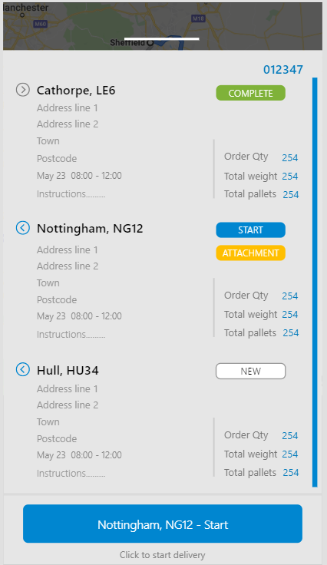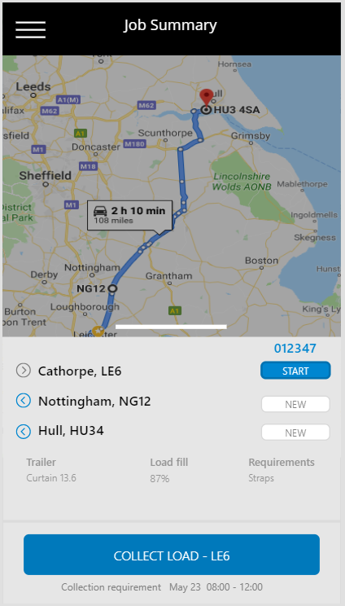
7. 8.
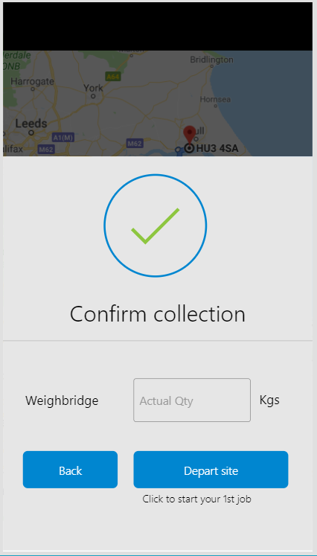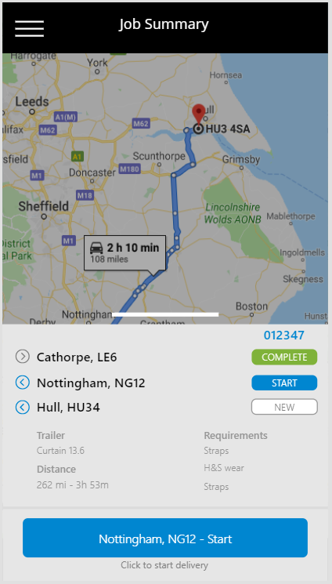

9. 10.
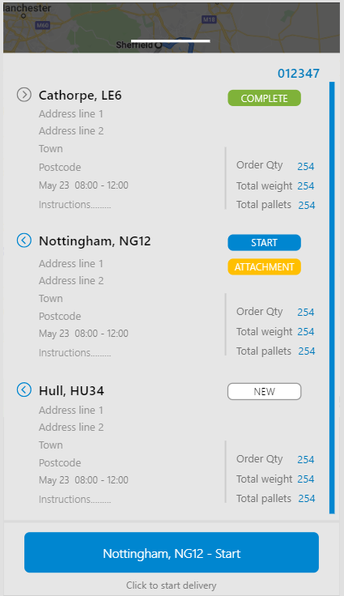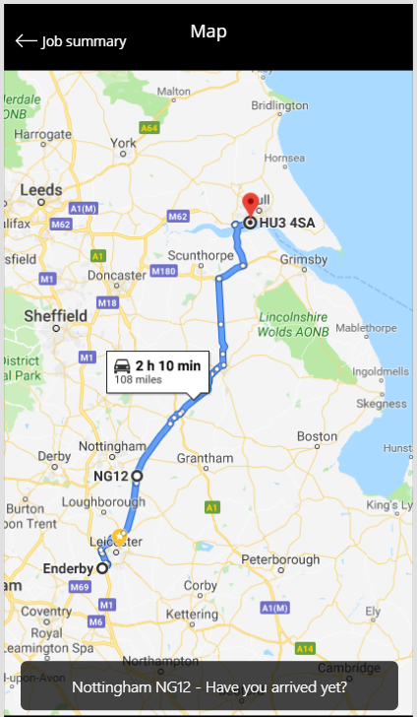
11. Click Job Summary on map 12. Detail screen. Click CONTINUE
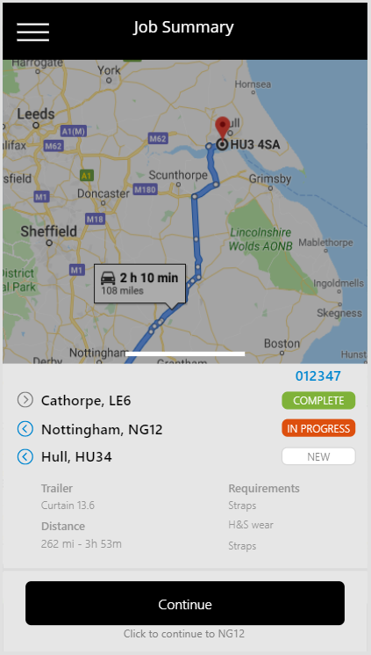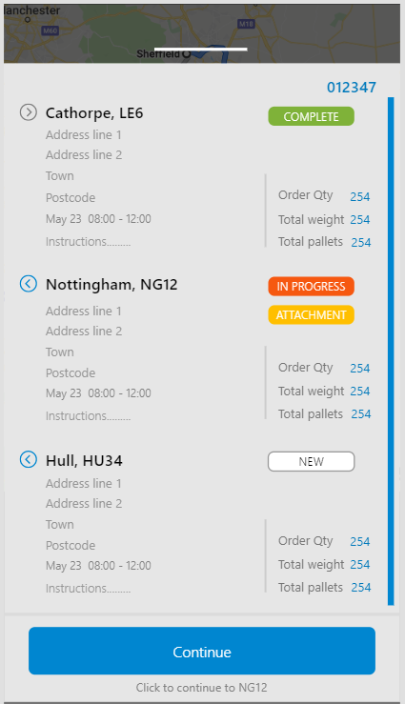

13. Click ‘NO’ 14. Click on bottom button as ‘You have arrived’
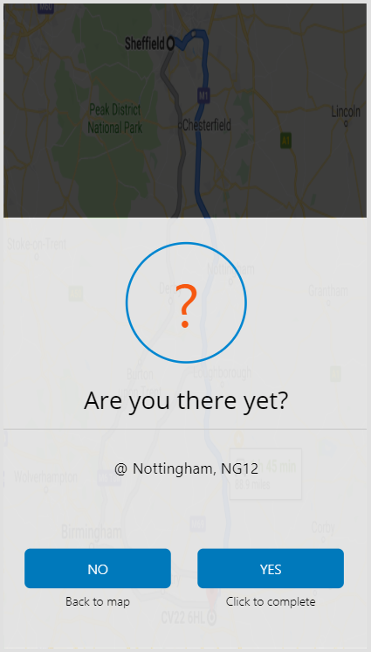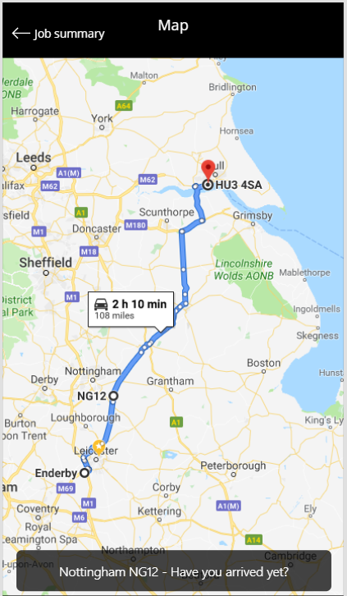
15. Click ‘Yes’ to confirm 16. Click ‘No,’ as all is good!
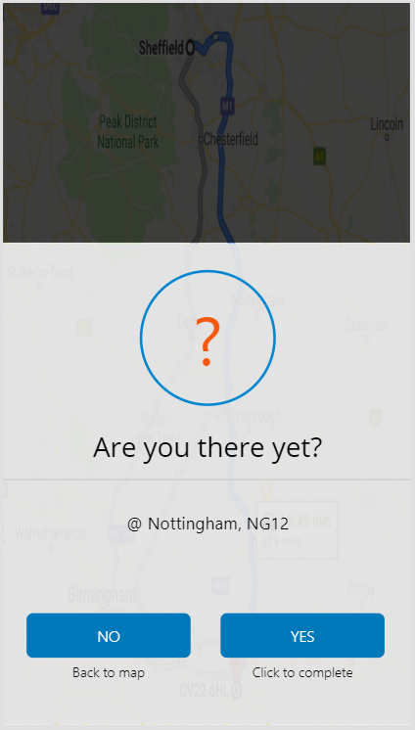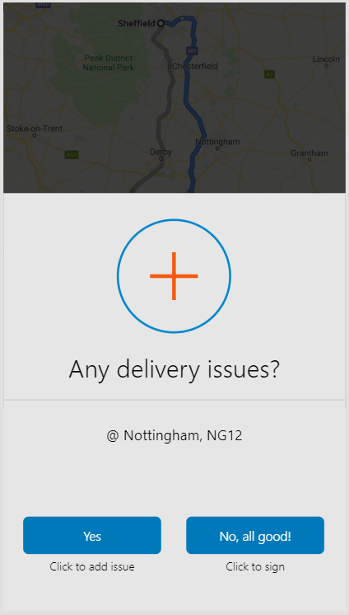

17. Add issue 18. Back
